Reset Button Test Case

Revision History
Version | Date | Author | Description
0.1 | 2008-12-11 | Zhao haihui | Initial version

Table of Contents
Glossary and Abbreviations

Introduction
Default, reset button be enabled, we can reboot or reset AP by pressing reset button. We can use CLI to disable reset button, after disable reset button, we can not reset AP by pressing reset button, but we still can reset AP by executing CLI.

Test point or strategy

Reset button with default(enable) state

Reboot AP by pressing reset button more than 1s less than 5s

Press the button more than 5s, reboot and load the default factory configuration.(no bootstrap configuration)

Press the button more than 5s, reboot and load the bootstrap configuration.

Press the button less than 1s, no change

Check if can reset config by executing CLI

Reset button with disable state

Disable reset button, press reset button between 1s and 5s, check if AP will reboot and if load default or bootstrap config

Disable reset button, press reset button more than 5s, check if AP will reboot and if load default config

Disable reset button, press reset button more than 5s, check if AP will reboot and if load bootstrap config

After disable reset button, check if we can reset AP by executing CLI

Disable reset button, check if can use one-off user to reset config

Topology




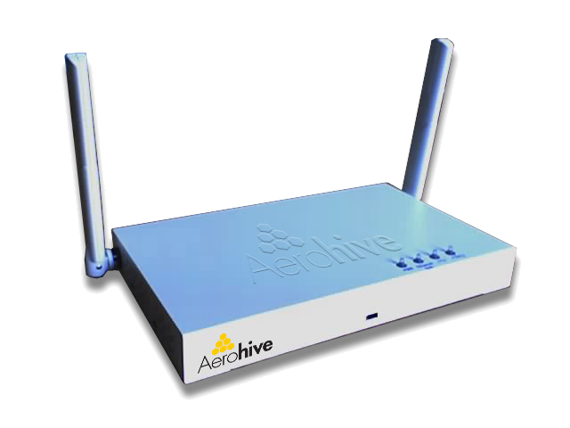

Topology 1

Test Case

Reset button with default(enable) state

FT_Reset-Button_Enable_1
Case ID | FT_Reset-Button_Enable_1
Priority | High | Automation Flag | No
Topology to use | Topology 1
Description | Reboot AP by pressing reset button more than 1s less than 5s
Pre-condition | Create some configurations and save config
Test procedure | Press reset button more than 1s less than 5s
Expect result | AP reboot and config don’t change

FT_Reset-Button_Enable_2
Case ID | FT_Reset-Button_Enable_2
Priority | Accept | Automation Flag | No
Topology to use | Topology 1
Description | Press reset button more than 5s, reboot and load the default factory configuration.(no bootstrap configuration)
Pre-condition | Create some configurations and save config
Test procedure | Press the button more than 5s
Expect result | AP reboot and enter CLI wizard, AP load default setting

FT_Reset-Button_Enable_3
Case ID | FT_Reset-Button_Enable_3
Priority | Accept | Automation Flag | No
Topology to use | Topology 1
Description | Press reset button more than 5s, reboot and load the bootstrap configuration.
Pre-condition | Create some configurations
Test procedure | 1. Save config running to bootstrap  2. Press reset button more than 5s
Expect result | 1. Bootstrap config same with running-config  2. AP reboot and load bootstrap config(check running config)

FT_Reset-Button_Enable_4
Case ID | FT_Reset-Button_Enable_4
Priority | Low | Automation Flag | No
Topology to use | Topology 1
Description | Press reset button less than 1s, no change
Pre-condition | AP with default setting
Test procedure | Press reset button less than 1s
Expect result | AP no change

FT_Reset-Button_Enable_5
Case ID | FT_Reset-Button_Enable_5
Priority | Low | Automation Flag | No
Topology to use | Topology 1
Description | Check if can reset config by executing CLI
Pre-condition | Create some configurations and save config
Test procedure | 1. Check reset button state by show reset-button  2. Execute command “reset config”  3. Check running config
Expect result | 1. Reset button is enabled  2. AP reboot and enter CLI wizard  3. Running config don’t exist, AP load default setting

Reset button with disable state

FT_Reset-Button_Disable_1
Case ID | FT_Reset-Button_Disable_1
Priority | High | Automation Flag | No
Topology to use | Topology 1
Description | Disable reset button, press reset button between 1s and 5s, check if AP will reboot and if load default or bootstrap config
Pre-condition | Disable reset button  Create some configurations and save config
Test procedure | Press reset button between 1s and 5s
Expect result | AP reboot and config don’t change

FT_Reset-Button_Disable_2
Case ID | FT_Reset-Button_Disable_2
Priority | Accept | Automation Flag | No
Topology to use | Topology 1
Description | Disable reset button, press reset button more than 5s, check if AP will reboot and if load default config
Pre-condition | Disable reset button  Create some configurations and save config
Test procedure | 1. Check reset button state by show reset-button  2. Press reset button more than 5s  3. Check running config
Expect result | 1. Reset button with disabled state  2. AP reboot  3. Running config don’t change

FT_Reset-Button_Disable_3
Case ID | FT_Reset-Button_Disable_3
Priority | Accept | Automation Flag | No
Topology to use | Topology 1
Description | Disable reset button, press reset button more than 5s, check if AP will reboot and if load bootstrap config
Pre-condition | Save some configurations to bootstrap  Disable reset button  Create some configurations and save config(current config different from bootstrap config)
Test procedure | 1. Check reset button state by show reset-button  2. Press reset button more than 5s  3. Check running config and bootstrap config
Expect result | 1. Reset button with disabled state  2. AP reboot  3. Running config and bootstrap config don’t change

FT_Reset-Button_Disable_4
Case ID | FT_Reset-Button_Disable_4
Priority | Middle | Automation Flag | No
Topology to use | Topology 1
Description | After disable reset button, check if we can reset AP by executing CLI
Pre-condition | Disable reset button  Create some configurations and save config
Test procedure | Execute “reset config” command
Expect result | AP reboot and enter CLI wizard, running config don’t exist, AP with default setting

FT_Reset-Button_Disable_5
Case ID | FT_Reset-Button_Disable_5
Priority | Low | Automation Flag | No
Topology to use | Topology 1
Description | Disable reset button, check if can use one-off user to reset config
Pre-condition | Save some configurations to bootstrap  Disable reset button  Create some configurations and save config  Generate a one-off user by serial number
Test procedure | 1. Check reset button state by show reset-button then logout  2. Use one-off user to login AP  3. Check running config and bootstrap config
Expect result | 1. Reset button with disabled state  2. AP reboot and enter CLI wizard  3. Running config and bootstrap config don’t exist, AP load default setting

CLI (Automation Status: Yes/No)
AH-035e00#reset-button
reset-config-enable Enable the reset button to reset the HiveAP to its
factory default settings or, if set, to a bootstrap
config (Default: enabled)
AH-035e00#no reset-button
reset-config-enable Disable the reset button to reset the HiveAP to its
factory default settings or, if set, to a bootstrap
config (Default: enabled)
AH-035e00#show reset-button
Reset configure: Enabled

Customer Issue or Typical Bug

